What is it?
Gyrodactylosis, caused by the parasite Gyrodactylus salaris, is a serious fish disease that infects the skin, gills and fins of salmon, trout and some other species of freshwater fish. Barely visible to the naked eye, the parasite can cause serious damage to some UK strains of Atlantic salmon. If the GS parasite were to be introduced into UK waters, entire river systems could quickly become infected, resulting in the destruction of valuable freshwater stocks of salmon. Over 20 Norwegian rivers have been affected.
Where is it found?
All the EU countries shown, including those of unknown status should be treated as having the parasite and gear disinfected accordingly.
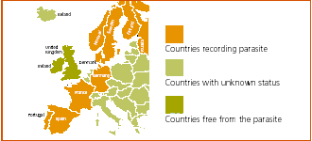

How is it spread?
The parasite is very hardy and may be inadvertently introduced by fishermen. It is capable of surviving for several days in damp conditions such as plastic bags, wet angling equipment (e.g. bags, waders, landing nets, lines, flies etc.,).
What should you do?
If you have been fishing in one of the non-British/Irish countries shown then on your return, and before fishing again in the UK, you should take the following precautions to ensure that your equipment is not contaminated. All fishing equipment should be thoroughly cleaned and then treated to kill any parasites by one of the following methods - don't take short cuts, it's too risky:
• Drying at a minimum temperature of 20°C for at least two days, or
• Heating for at least one hour at a temperature above 60°C, or
• Deep freezing for at least one day, or
• Immersion in a solution suitable for killing Gyrodactylus salaris for a minimum of ten minutes. A list of successful chemicals, plus further information, can be found in the Defra leaflet (Acrobat 704 Kb) on GS. Show me

